EXP 09

**Create a simple cloud software application for Hospital information system for SIMATS Hospital using any Cloud Service Provider to demonstrate SaaS with fields of patient name, age, address, phone, email, Attender name, attender phone, doctor name, diseases, etc.**

STEP 1: Sign in to the zoho.com and click the creator option

STEP 2: After enter into the creator click the create solution

R.Akash 192121091

STEP 3: To create the application by select the application

STEP 4: After selection the application to create the new component form

R.Akash 192121091

STEP 5: Click and open the scratch from the form

STEP 6: Enter the name of the form to crate the form

R.Akash 192121091

STEP 7: choose any form of template to create the page form

STEP 8: To create the form pages of the application by basic fields

R.Akash 192121091

STEP 9: The first form is to create the patient deatils

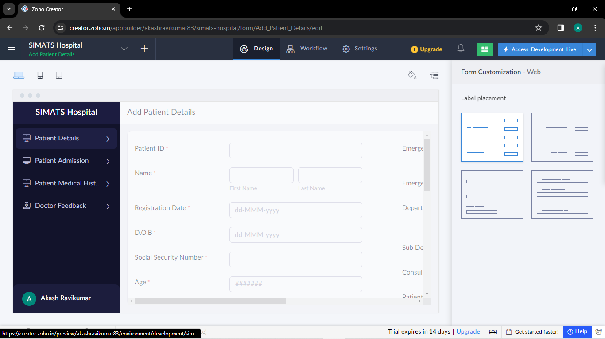

STEP 10 : The second form is to create the patient admission form

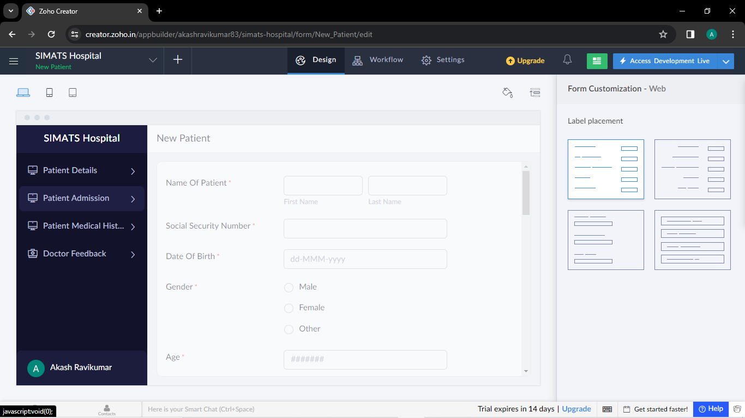

R.Akash 192121091

STEP 11: The third form is to create the patient medical history form

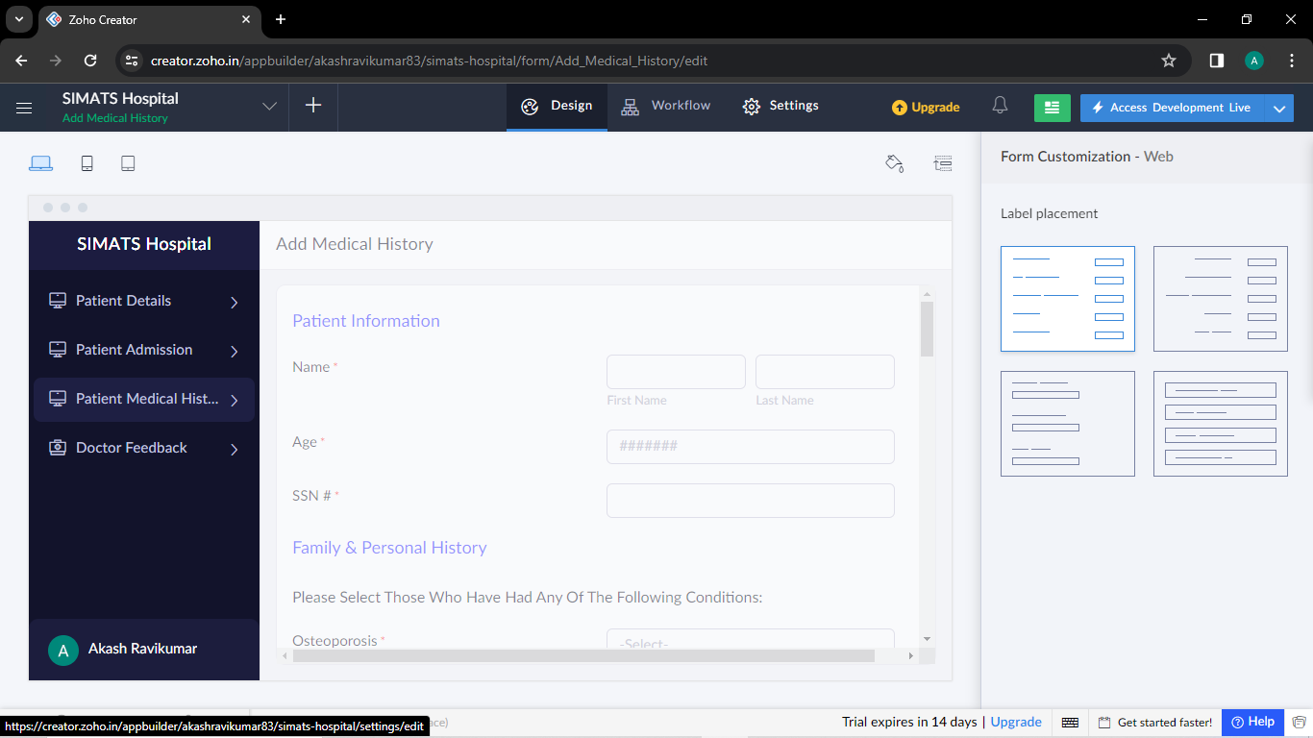

STEP 12: The fourth form is create the doctor feedback form

R.Akash 192121091